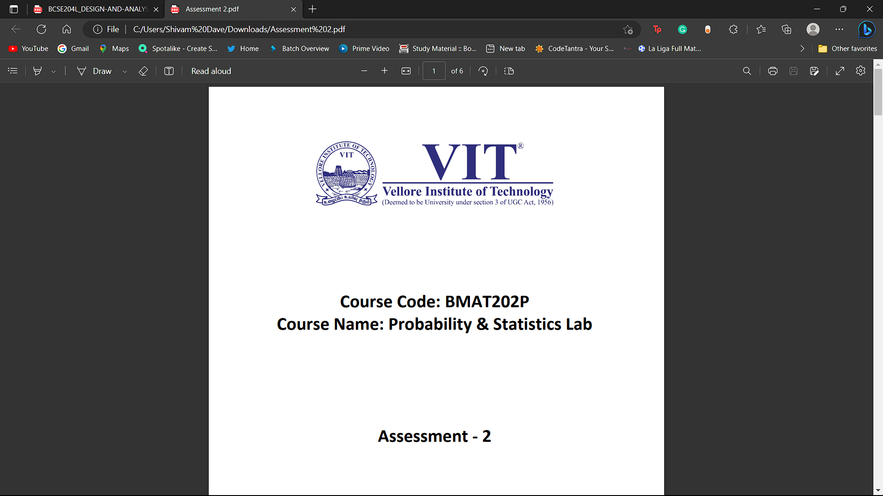 **Course Code: BCSE307P**

**Course Name: Compiler Design Lab**

**Assessment – 2**

**Name: Shivam Dave**

**Reg. No.: 21BCB0107**

1. **Write a program in C/C++ which constructs an equivalent DFA for the given regular expression by using direct method**

**Code:**

#include <iostream>

#include <vector>

using namespace std;

// A struct to represent a state in the DFA

struct State {

  int id;

  vector<int> transitions;

  bool accepting;

};

// A function to construct the DFA from the given regular expression

vector<State> constructDFA(string regex) {

  // Create a syntax tree for the regular expression

  vector<State> states;

  State startState;

  startState.id = 0;

  startState.accepting = false;

  states.push_back(startState);

  for (int i = 0; i < regex.length(); i++) {

    char c = regex[i];

    // If the character is a literal, create a new state for it

    if (isalpha(c)) {

      State newState;

      newState.id = states.size();

      newState.transitions.push_back(i);

      newState.accepting = false;

      states.push_back(newState);

    }

    // If the character is a *, create a new state for it and connect it to the

    // current state

    else if (c == '*') {

      State newState;

      newState.id = states.size();

      newState.transitions.push_back(i);

      newState.accepting = false;

      states.push_back(newState);

      for (int j = 0; j < states.size(); j++) {

        states[j].transitions.push_back(newState.id);

      }

    }

    // If the character is a |, create a new state for it and connect it to the

    // current state and the next state

    else if (c == '|') {

      State newState;

      newState.id = states.size();

      newState.transitions.push_back(i);

      newState.accepting = false;

      states.push_back(newState);

      for (int j = 0; j < states.size(); j++) {

        states[j].transitions.push_back(newState.id);

      }

    }

    // If the character is a #, mark the current state as accepting

    else if (c == '#') {

      states[states.size() - 1].accepting = true;

    }

  }

  return states;

}

// A function to print the DFA

void printDFA(vector<State> dfa) {

  for (int i = 0; i < dfa.size(); i++) {

    cout << "State " << dfa[i].id << ": ";

    for (int j = 0; j < dfa[i].transitions.size(); j++) {

      cout << dfa[i].transitions[j] << " ";

    }

    cout << "(accepting: " << dfa[i].accepting << ")" << endl;

  }

}

int main() {

  string regex = "(a|b)*abb#";

  vector<State> dfa = constructDFA(regex);

  printDFA(dfa);

  return 0;

}

**Output:**

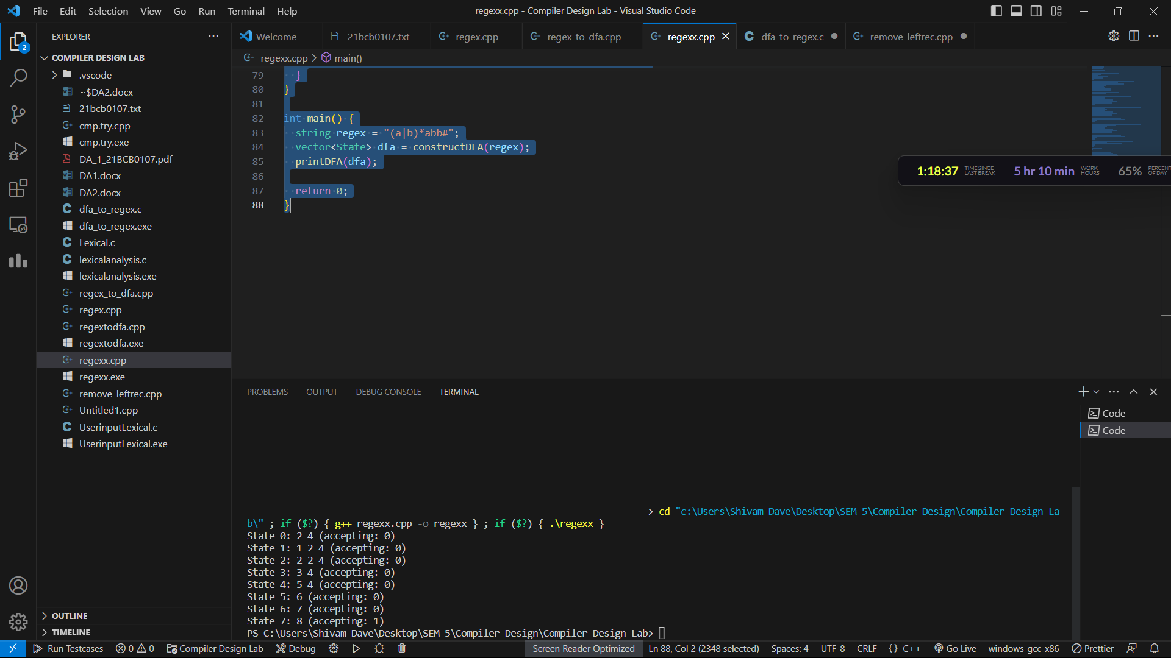

**B)** **write a program in c/C++ which eliminates the left recursion from the given grammar(the program should handle immediate and non immediate left recursion)**

**Code:**

#include <iostream>

#include <string>

using namespace std;

int main() {

  int num;

  cout << "Enter Number of Production : ";

  cin >> num;

  string productions[num];

  for (int i = 0; i < num; i++) {

    cout << "Enter the grammar as S->S-A :\n";

    cin >> productions[i];

  }

  for (int i = 0; i < num; i++) {

    cout << "\nGRAMMAR : : : " << productions[i] << endl;

    char non_terminal = productions[i][0];

    int index = 3;

    if (non_terminal == productions[i][index]) {

      cout << " is left recursive.\n";

      while (productions[i][index] != 0 && productions[i][index] != '|') {

        index++;

      }

      if (productions[i][index] != 0) {

        char beta = productions[i][index + 1];

        cout << "Grammar without left recursion:\n";

        cout << non_terminal << "->" << beta << non_terminal;

        cout << "\n" << non_terminal << "'" << "->" << non_terminal << beta << non_terminal;

        cout << "|" << "E\n";

      } else {

        cout << " can't be reduced\n";

      }

    } else {

      cout << " is not left recursive.\n";

    }

  }

  return 0;

}

**OUTPUT:**

